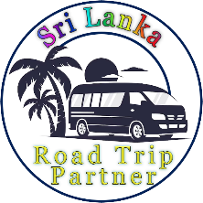

Sri Lanka Road Trip Partner

Explore Sri Lanka with us and create unforgettable memories.

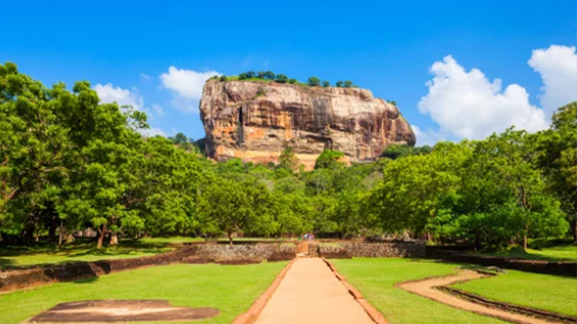
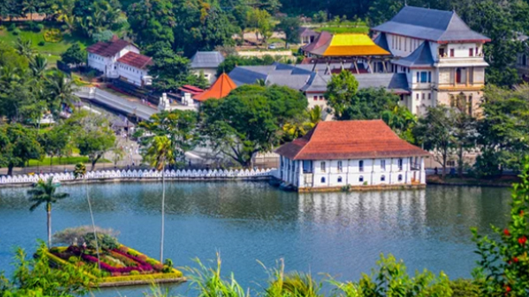

1 Day - Sigiriya
Sigiriya, also known as Lion Rock, is an ancient rock fortress and palace ruin, offering panoramic views and intricate frescoes.
Things to Do:
- Climb Sigiriya Rock Fortress
- Climb Pidurangala Rock
- Visit Dambulla Cave Temple
- Go on a Village Safari
- Go on a jeep Safari on Minneriya / Kaudulla National Park
- Ayurvedic massage treatments

2 Day - Kandy
Kandy is a cultural hub, home to the Temple of the Sacred Tooth Relic and the picturesque Kandy Lake.
Things to Do:
- Visit Temple of the Tooth Relic
- Visit Peradeniya Botanical Gardens
- Watch Kandyan Cultural Dance Show
- Visit Ambuluwawa Tower
- Visit Herbal Spice Gardens

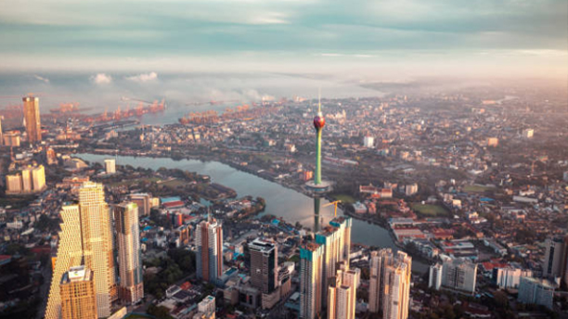
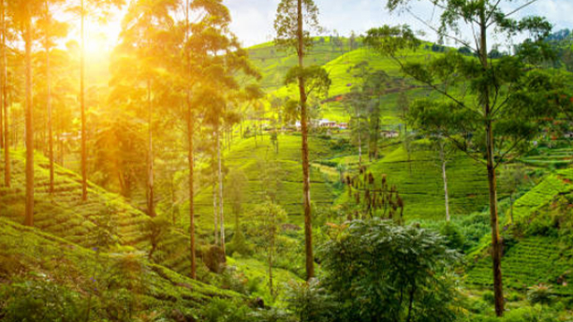

3 Day - Nuwara-eliya
Nuwara Eliya, often referred to as "Little England," is known for its cool climate, tea plantations, and colonial-era architecture.
Things to Do:
- Experience Ramboda Falls
- Visit Tea Factory
- Visit Seetha Amman Kovil
- Visit Haggala Botanicle Garden
- Jeep Ride on Moon-Plains
- Visit Post Office (A colonial-era Tudor-style building.)

4 Day - Colombo
Colombo is the bustling commercial capital of Sri Lanka, offering a mix of modern urban life and colonial charm.
Things to Do:
- Visit Gangaramaya Temple
- Visit the Red Mosque (Jami Ul-Alfar Mosque)
- Visit Lotus Tower
- Explore the Colombo National Museum
- Visit the Pettah Market
- Explore Dutch Hospital Shopping Precinct
- Experience Colombo's Nightlife
- Walk Along Galle Face Green

Sri Lanka Road Trip Partner

Package 1
(4 Days / 3 Nights )

We offer our own well-planned travel packages, and we welcome you to customize your own experience as well.

Have a Question?

Call Or WhatsApp :- + 94 77 19 53 880
Email :- malindutissera@gmail.com

Let's turn your travel dreams into reality one incredible adventure at a time!

